

**UNIVERSIDAD TECNOLÓGICA DE**

**SAN LUIS RIO COLORADO**

**REACTIVO PARCIAL II**

**MTRO. RICARDO ALEJANDRO SOTO MORALES**

**AUTOR: VICTOR MANUEL GALVAN COVARRUBIAS**

San Luis Rio Colorado, Sonora Julio, 2020

**I. Answer the following questions (value 2% each)**

1.- With your own words, explain what a collaboration diagram is for.

A collaboration diagram shows the order of the steps in a process. In this process are the actors and objects. You can see how the process is completed through messages and operations between the different actors and objects present in the diagram.

2.- Draw and explain the class symbol.

-The name of the class is placed in the first space.

-In the second space all the attributes and characteristics of the class are placed. Also if they are private or public. (+ or -)

-In the third space all the methods and the class are placed. Also if they are private or public. (+ or -)

|  |
| --- |
| People |
| +people_id  +name  +lastname  -age  -gender |
| +print_people{}  +add_people{}  -delete_people{} |

Illustration 1: Example of the class symbol.

3.- What does UML mean?

Unified Modeling Language.

4.- What is an attribute?

They are the characteristics by which a class is defined. An example is the variables and constants that are handled in each class. Depending on the class, the variables and constants will be different.

5.- What are the components diagrams?

It is a diagram that graphically shows how a system is divided. The diagram is made up of packages that contain either physical or logical components of the system in question.

**II.-Carry out the following exercises (value 25%)**

1. Analyze and make the diagrams of use cases (5%), sequence (5%) and collaboration (5%) of a user when contracting the NETFLIX service taking into account that he will pay by credit card, since you have made the payment take into account the process of selecting a movie, watching it and closing your account.

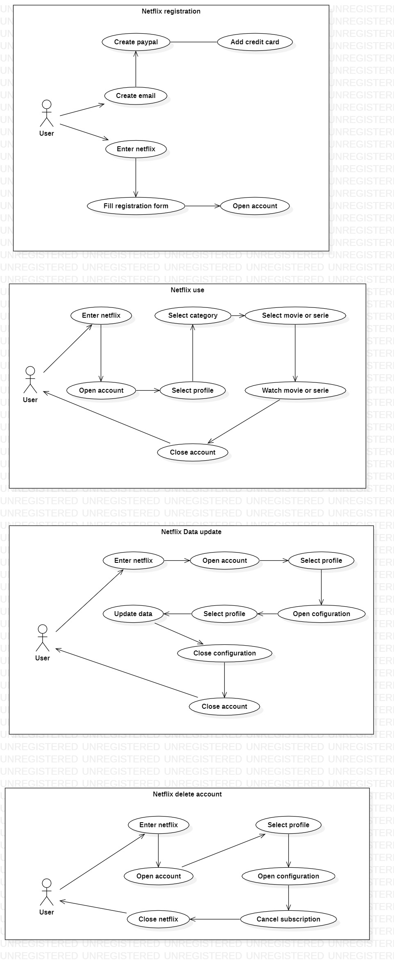





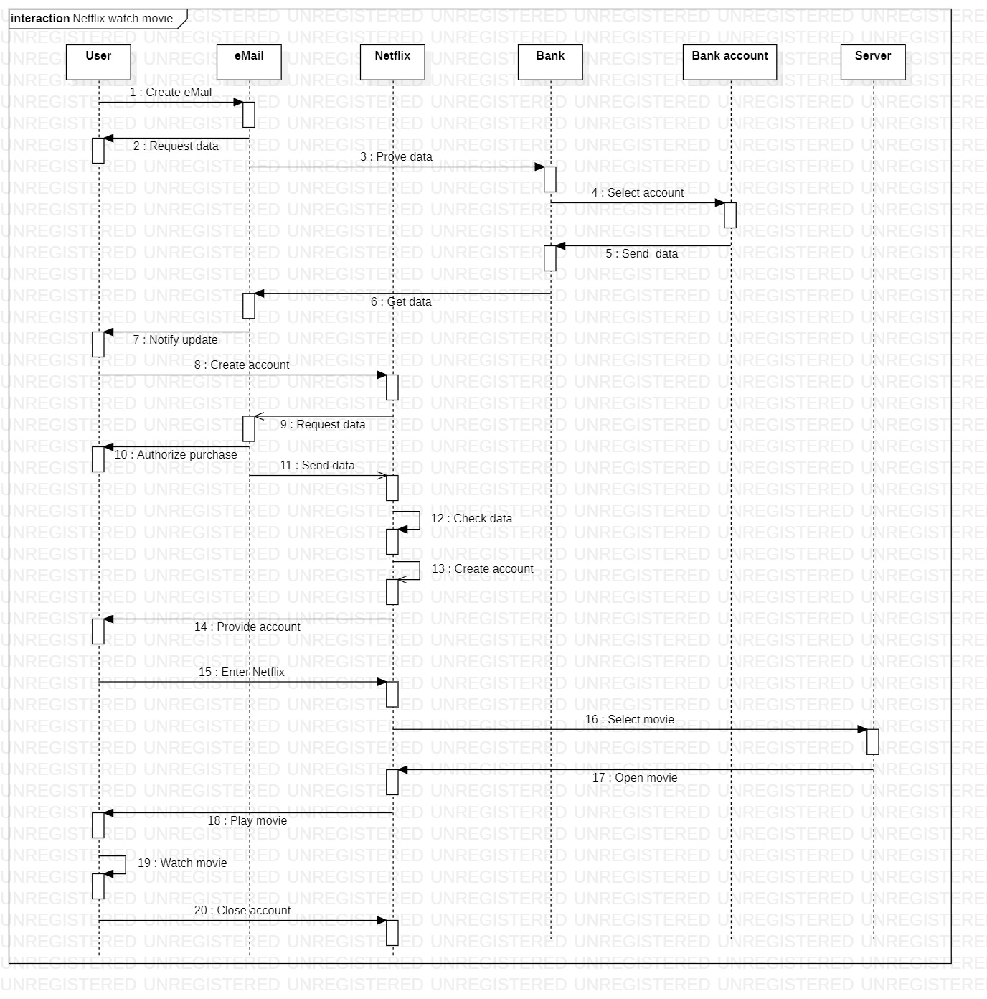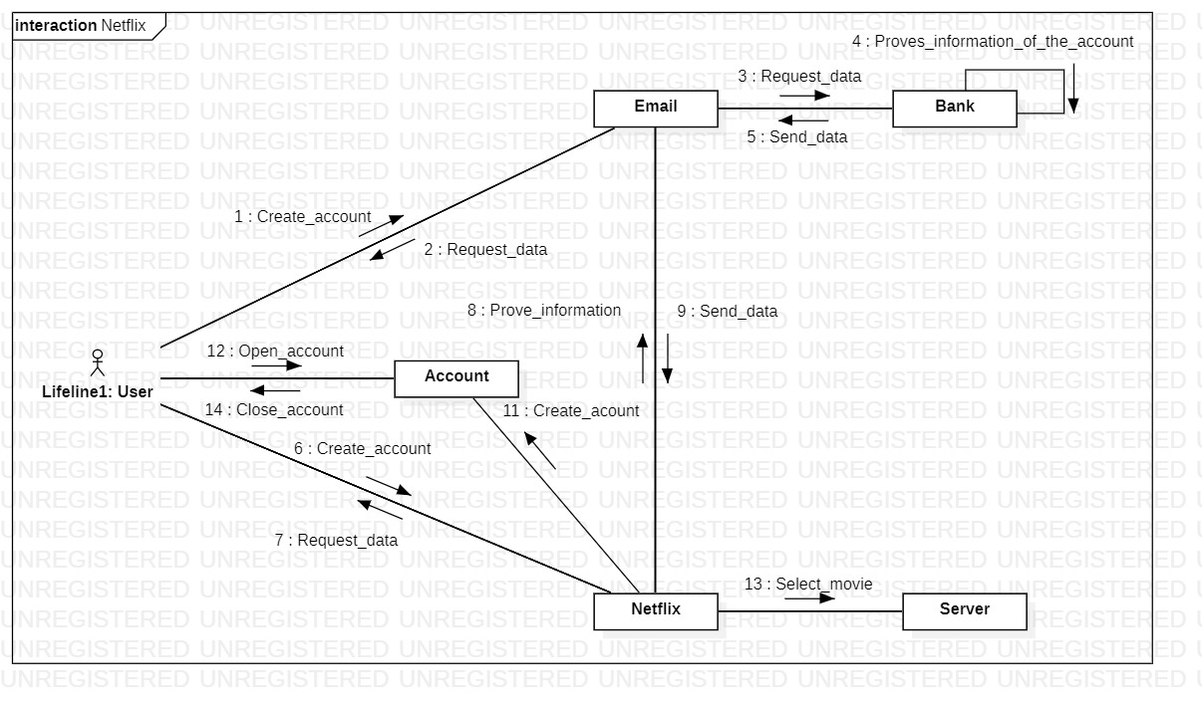

1. Make the component diagram of the AMAZON website taking into account the business model, the physical components, the logical components and the software with which said site was created (invented by yourself). 7%.

